ASSIGNMENT REPORT: MERN STACK DEVELOPMENT

Project Title: Secure User Authentication & Data Analytics System
Submitted By: Devendra Chharang

Department: B.Tech CSE (Data Science & Analytics)

Institution: JECRC University, Jaipur

Submission Date: March 12, 2026

MONGODB AGGREGATION FRAMEWORK
1. Concept Overview
The MongoDB Aggregation Framework is a powerful processing engine that allows for data transformation and computation directly at the database level. Instead of fetching all raw documents to the frontend, we use "Pipelines" to process data into meaningful summaries.
2. Practical Implementation (The 'Kaise')
In my project, I implemented an aggregation pipeline in salesController.js to generate business analytics. The pipeline consists of three critical stages:
Stage 1: $match (Data Filtering)
Logic: { $match: { status: "shipped" } }
Kyun: It filters out unwanted records (like cancelled or pending orders) early in the process. This optimizes performance by reducing the number of documents to be processed in subsequent stages.
Stage 2: $group (Data Computation)
Logic: { $group: { _id: "$category", totalRevenue: { $sum: "$amount" } } }
Kyun: This is where the actual "Math" happens. It groups all orders based on their category and calculates the sum of the amount field for each group.
Stage 3: $sort (Data Organization)
Logic: { $sort: { totalRevenue: -1 } }
Kyun: It arranges the results in descending order, ensuring the top-performing categories are presented first to the user.
3. Strategic Benefit
Using aggregation pipelines instead of simple find() queries ensures:
Lower Network Latency: Only the calculated results are sent to the client.
Server Efficiency: The computation happens on the database server, which is optimized for such heavy operations, making the application scalable.

Q2: HIGHER-ORDER COMPONENTS (HOCs) IN REACT
1. Technical Definition
A Higher-Order Component (HOC) is an advanced pattern in React for reusing component logic. It is a function that takes a component and returns a new enhanced component.
2. Implementation: The ProtectedRoute
In my application I implemented a ProtectedRoute.js HOC to manage security.
The Logic: Instead of writing authentication checks in every dashboard (Admin, Manager, User) I wrapped these components inside my HOC.
The Process: 1. The HOC retrieves the user's JWT Token and Role from localStorage.
2. It validates if the token exists and matches the required permissions for that specific route.
3. If authorized, it renders the requested page; otherwise, it redirects the user to the /login page.
3. Why Use HOCs:-
Code Reusability: It follows the DRY (Don't Repeat Yourself) principle. The authentication logic is written once but reused across multiple routes.
Separation of Concerns: The UI components only focus on displaying data, while the HOC handles the security logic.
Scalability: Adding a new role only requires a simple update in the HOC rather than changing every page.

Q3: JWT AUTHENTICATION & SECURITY FLOW
1. Security Architecture :-
Standard session-based authentication can be heavy on the server. I implemented JSON Web Tokens (JWT) because they are stateless, secure, and highly scalable for MERN applications.
2. The Authentication Lifecycle :-
The security flow in this project follows a 4-step process:
Secure Hashing (Bcrypt):
Passwords are never stored in plain text. When a user registers, the password is encrypted using the Bcrypt algorithm with a salt factor. This ensures data privacy even in the case of a database breach.
Token Generation:
Upon a successful login, the server verifies the credentials and generates a unique JWT signed with a Secret Key (stored in .env). This token contains user identity and role information.
Client-Side Persistence (LocalStorage):
The generated token is sent to the frontend and stored in LocalStorage. This allows the user to remain logged in even after refreshing the browser.
Authorization Headers:
For every subsequent request to protected routes (like the Dashboard), the token is attached to the HTTP Authorization Header . The server verifies this token before granting access.
3. Error Handling & Validation
Duplicate Key Protection: The system handles MongoDB E11000 errors to prevent duplicate email registrations, ensuring data integrity.
Token Expiry: The system is designed to reject expired or tampered tokens, maintaining a high security standard.

User Registration Flow
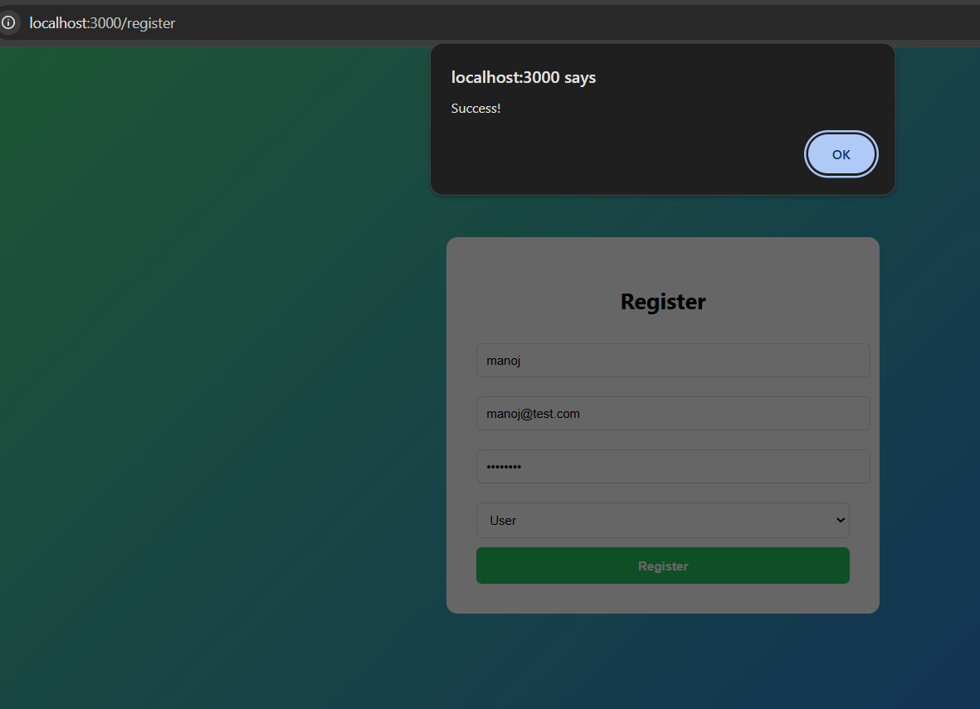Description: This screenshot confirms the successful registration of a user and the backend ability to hash passwords and store data in MongoDB.

2. Login & Token Generation
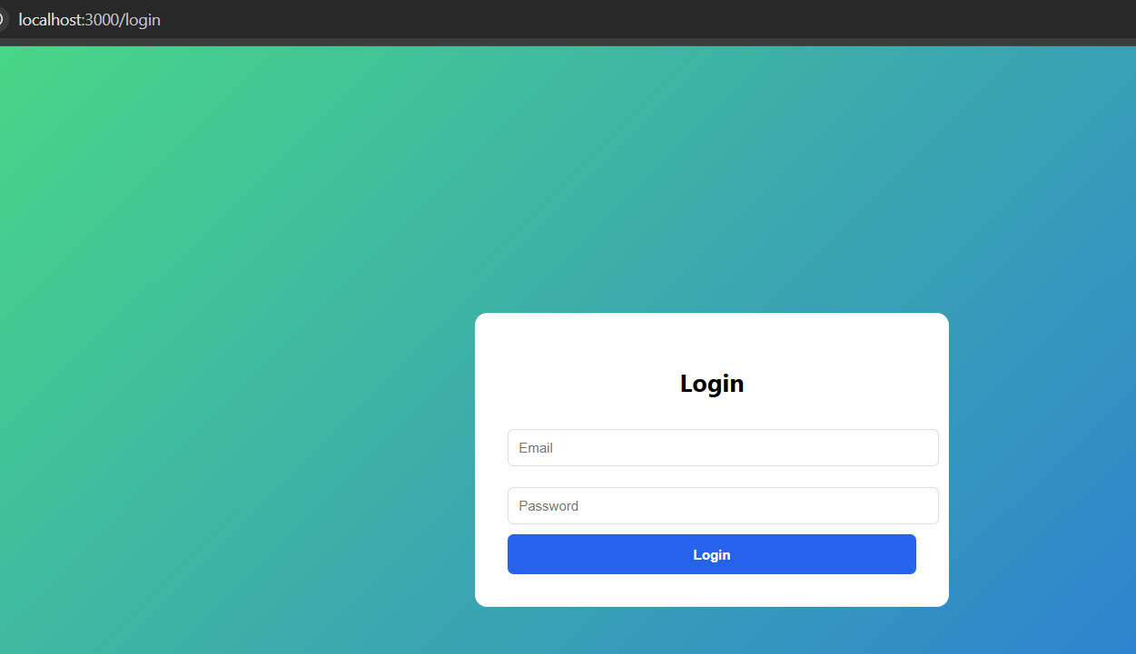

Description: Proof of successful authentication. Upon this step the JWT token is generated and stored in the browser LocalStorage.

3. Backend Validation (Postman Test)
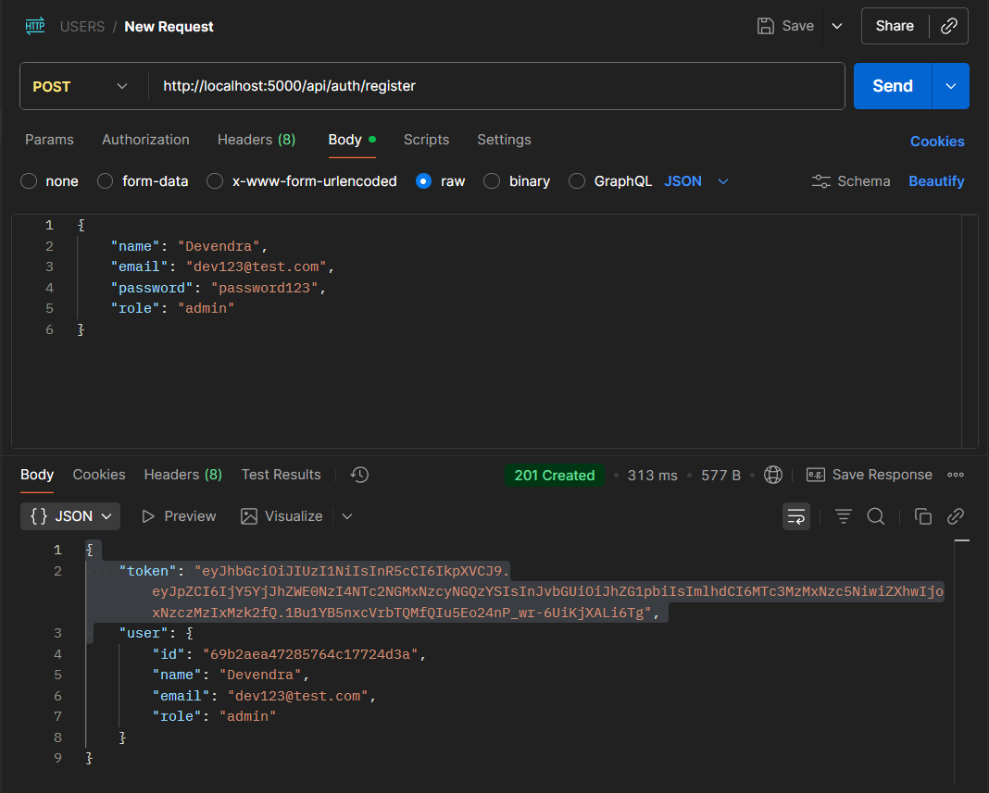
Description: This demonstrates the backend validation logic that prevents duplicate email registrations, ensuring data integrity.

4. Production Deployment (Vercel)
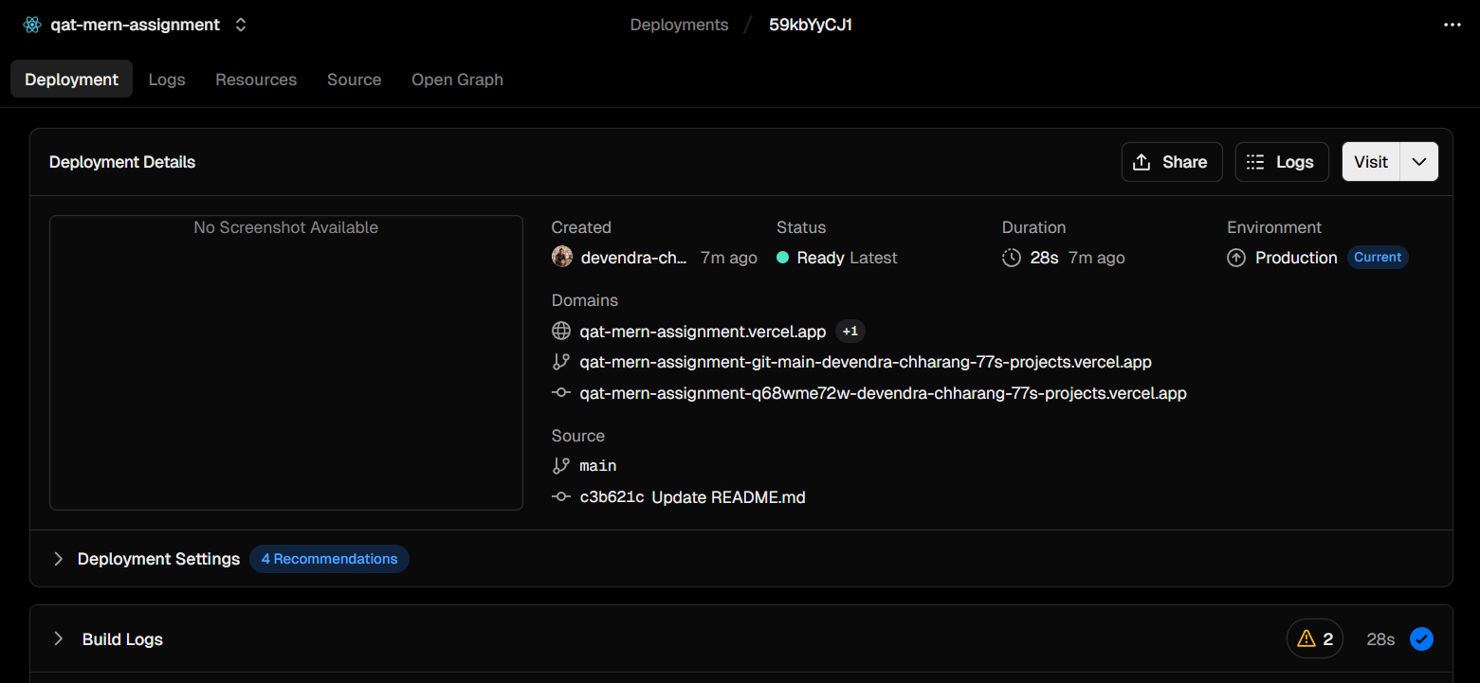
Description: The application is live and hosted on Vercel. All routes and client-side navigation are handled via vercel.json rewrites.

